**Wild Activities Challenging Kirklees Young people 2014**

**‘WACKY’**

Duke of Edinburgh’s Award Office

[www.kirkleesdofe.org](http://www.kirkleesdofe.org)

Netherton Village Hall

330a-332 Meltham Road

Huddersfield

HD4 7EX

Tel: 01484 222374

Fax: 01484 222394

WACKY offers a packed programme of activities for young people with disabilities aged 13 - 25 to take part in over the summer holidays. Projects will be based at The DofE Marina Project Shepley Bridge Marina Huddersfield Road Mirfield WF14 9HR. Activities will run from 10.30 – 3.30 daily. There will be an opportunity to choose from at least ten different activities each day, which were chosen by groups of young people earlier in the year.

The activities on offer include arts, crafts, DJ workshops, circus skills, digital photography and music. The more energetic amongst you will enjoy a choice of sporting activities inc: canoeing, cycling, fishing, bush craft, archery and rock climbing. We have arranged visits to places of interest and the very popular themed narrow boat trips. Pampering sessions, healthy eating and environmental projects have also been requested and for those exhibitionists we have our very own ‘WACKY’s Got Talent’.

WACKY is an activity programme and we welcome all young people with a disability however we do not have staff to provide one to one or two to one support. We would encourage you to come along with your personal assistant/carer if required; this has been the case over many years and has worked really well.

Arrangements have been made with the Ship Inn on Stenard Lane Mirfield to use their car park for pick up and drop off. If you are coming in a vehicle please arrange to be dropped off in the car park at 10.15am. You can then be collected at the end of WACKY ay 3.45pm in the Ship Car Park. The venue is easily accessible by public transport and the bus stops are just across the road from the Marina if you are coming from Huddersfield and around 10 meters from the Marina entrance if you are travelling from Dewsbury.

A packed lunch & drink will be required each day and £3.00 subs and a small amount of spending money for tuck shop or an ice cream. A towel and a change of clothes are required for water activities. A sun hat and cream and a waterproof jacket will prepare you for our varied British summer. To get a flavor of last year’s WACKY watch the film on www.kirkleesdofe.org.

Due to the success of previous WACKY sleep overs we are going to offer this opportunity each Thursday of the WACKY week. You can take part in fun activities throughout the day and the evening including a fun treasure hunt concluding with a barbecue and sing song around the camp fire. We will be camping in tents and a tipi or you can sleep in a den that you have built if you prefer. We will get up in the morning and have breakfast and then get on with another WACKY day and you can be collected as normal on Friday at 3.30. Those wanting to get involved will need to bring warm clothes an overnight bag, any medication and a sleeping bag. We will provide the food and drink. There are 20 sleepover places available each week which will be allocated on a first come basis, these will be £10 per person per night and must be booked and paid for in advance to allow us to make appropriate arrangements. Please make cheques payable to Kirklees Council.

To book your place please complete and return the attached Registration Form and send it to the office at the address above. We only have the capacity to accommodate around fifty young people per day so to avoid disappointment a prompt reply is advised. It is recommended that you keep a note of all the dates you have booked to avoid any confusion.

Please don’t hesitate to give me a call on the above number if you require any further information. I believe we have the perfect ingredients for a fantastic summer. All we need now is you, so don’t delay book today!!

Thank you for your interest and here’s to a fun summer!

Yours Sincerely

Denise Bedford

Denise Bedford MBE

Duke of Edinburgh’s Award Manager

**DofE Marina Project** Shepley Bridge Marina

Huddersfield Road Mirfield WF14 9HR

Ship Inn Public House Car Park

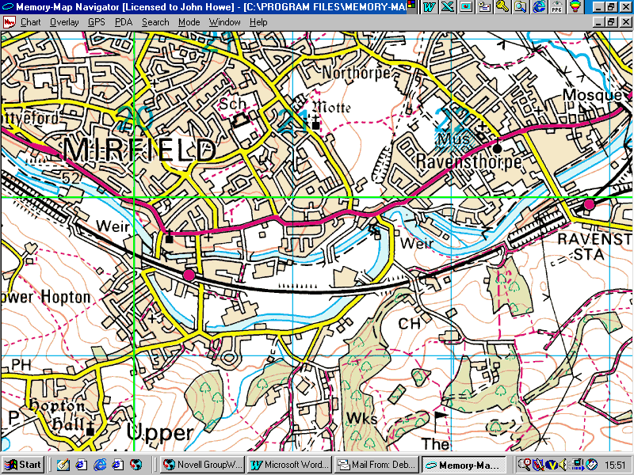

Shepley Bridge Marina is on the A644 (Huddersfield Road) opposite the Swan Public House Mirfield.

The 203 bus from Huddersfield Bus Station Stand Y or 262 bus from Dewsbury Bus Station stand 14.

If you are coming in a vehicle we have had permission to park in the:

**Ship Inn Car Park Stenard Lane, Mirfield, West Yorkshire WF14 8HB**

We will be waiting for you to be dropped & picked up in the Ship Inn car park at the appropriate times.

**Kirklees Young Peoples Service Registration Form MIS YP1 (2014)**



|  |  |  |  |
| --- | --- | --- | --- |
| Project Name | | | **WACKY (**Wild Activities Challenging Kirklees Young People) |
| Young People Service Team | | | DofE Team |
| Venue | | | DofE Marina Project Shepley Bridge Marina  Huddersfield Road Mirfield WF14 9HR |
| **Young Person Details \*** | | | |
| First name : | | Last name : | |
| Date of Birth: | | How did you hear about the project: | |
| Age: | | Gender : Male  Female | |
| Ethnicity : (Optional) please circle | | A1 Indian / A2 Pakistani / A3 Bangladeshi / A4 Asian (other)  B1 Black African/ B2 Black Caribbean/ B3 Black Other/ C1 Chinese /  M1 Mixed Race-Asian/ M2 Mixed race-Black/ M3 Mixed Race-European/ O1 Other/ V1 Vietnamese/ W1 White UK/Irish / W2 White European/ Rather not say | |
| **Address \*** | | | |
| Address1 : |  | | |
| Address2 : |  | | |
| County : |  | | |
| Postcode : |  | | |
| Home telephone : |  | | |
| Mobile telephone : |  | | |
| E mail Address : |  | | |
| **Emergency Contact \*** | | | |
| Name : |  | | |
| Telephone Numbers : |  | | |
| Relationship : |  | | |
| GP Details: Name:  Address:  Telephone |  | | |
| Can the GP be contacted if required: |  | | |
| **Additional Info.** | | | |
| Employment/ School/College : |  | | |
| Name of School / College : |  | | |
| Please give details  of any Disabilities: |  | | |
| How does the above affect daily functioning: |  | | |
| How does the young person communicate with others: |  | | |
| **Supplementary Info.** | | | |
| How do you get to the project : |  | | |
| Journey Time : |  | | |

**Statement of Consent**

1. I am aware these schemesare an **open access\*\*** scheme that may include sports, recreational, adventurous activities inc. rock climbing, canoeing, horse riding, sailing, arts and craft, advice information and guidance, media, health and food related projects.

2. I confirm the details of the participant are correct.

3. I know of no medical reason why the Young Person named above should not take part in any activities.

**If you do not agree to any of the following please delete as appropriate**

4. I understand that this scheme may enable young people to gain accreditation if the participant wishes to be considered for relevant Duke of Edinburgh’s/Arts Award/Paddle Power etc..

5. I understand during the scheme photographs and video footage will be taken and that images can be used for promotion and evaluation.

6. I agree that information may be shared with relevant partner agencies, to secure help for young person named, through available support and guidance.

Signature: (Young Person) Date:

Signature: (Parent/Guardian) Date:

**Data Protection Act 1998**: The information you provide to Kirklees Metropolitan Council is necessary for project management, development and audit, and also, when appropriate, to secure help for young persons through available support and guidance. It will be used only for those purposes. The Young People’s Service may share it with other Council Services and Partner Agencies where this is necessary for and consistent with the stated purposes. For the purpose of the Act the contact is The Information Access Officer, Room 108 High Street Buildings, Huddersfield, HD1 2NQ

What level of support does the young person require (e.g. one or two staff members)?

Does the young person use any special equipment? (e.g. wheelchair)?

What is the young person’s level of dependency for toileting?

What significant risks affect the young person?

If the young person becomes distressed or aggressive, how is the situation best dealt with?

**Medical Information**

Does the young person have any ongoing medical concerns? Please give details:

Is the young person taking regular medication? Please fill in medication below:

|  |  |  |  |
| --- | --- | --- | --- |
| **Name of Medication** | **Strength/**  **Suspension** | **Dosage** | **Directions** |
| *Eg. Paracetamol* | *500mg* | *2 tablets* | *With water, after food* |
|  |  |  |  |
|  |  |  |  |
|  |  |  |  |

Is this medication likely to need administering during the activity scheme? Please delete as applicable: Yes / No

|  |  |  |
| --- | --- | --- |
| **Time** | **Medication** | **Dosage** |
|  |  |  |

Is the young person epileptic? Yes / No If yes please inform us of the best action to take if required?

Does the young person have any allergies?

|  |  |  |
| --- | --- | --- |
| **Substance** | **Nature of Substance** | Symptoms |
| *eg. Penicillin* | *Antibiotic* | *Anaphylactic shock* |
|  |  |  |
|  |  |  |

I have ensured that Iunderstand that it is important for **his/her** safety and for the safety of the group that any rules and instructions given by activity scheme staff are obeyed. I undertake to inform the Leader of any changes in the young person’s health prior to the activity scheme. I am in agreement that those in charge may give permission for **my son/my daughter/ward** to receive medical treatment in an emergency.

Name of Person completing record: _______________________________________________

Relationship to participant (if applicable) _____________________________________________________________

Signature __________________________________________ Date _____________________

# Please indicate by ticking the appropriate box which days you would like to join in the WACKY Programme:

# 22 July [ ] 23 July [ ] 24July [ ] 24July + sleepover [ ] 25 July [ ]

# 29 July [ ] 30 July [ ] 31 July [ ] 31 July + sleepover [ ] 1 Aug [ ]

# 5 Aug [ ] 6 Aug [ ] 7 Aug [ ] 7 Aug + sleepover [ ] 8 Aug [ ]

**Please keep a note of the dates you have booked. We will not send out confirmation but will let you know by post or**

**e-mail if any of the dates you have chosen are unavailable. Otherwise we will expect you on the days you have indicated. If you could let us know if for any reason you cannot attend so we can re-allocate your place**.