


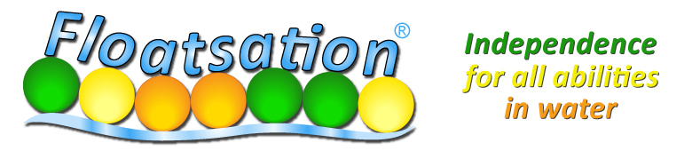

WEST YORKSHIRE TRAINING COURSE
(RESIDENTS FROM OTHER AREAS OF YORKSHIRE SHOULD ATTEND THEIR LOCAL SUB-REGIONAL COURSE HELD IN HUMBER, NORTH YORKSHIRE OR SHEFFIELD
(PLEASE ASK FOR DETAILS )

WEDNESDAY 14TH MAY, 1PM-3PM, BATLEY SPORTS & TENNIS CENTRE

Floatsation® can enable everyone to have fun in the water in a safe and confident way. It enables users to have fun while still allowing them to develop:
Confidence, Increased Self Esteem, Independence, Aquatic Skills, Water awareness, Spatial awareness, Team Skills, Relaxation in water, General relaxation, Safe exercise in water for all abilities and ages. See http://floatsation.com/train.html

What does the training session include?
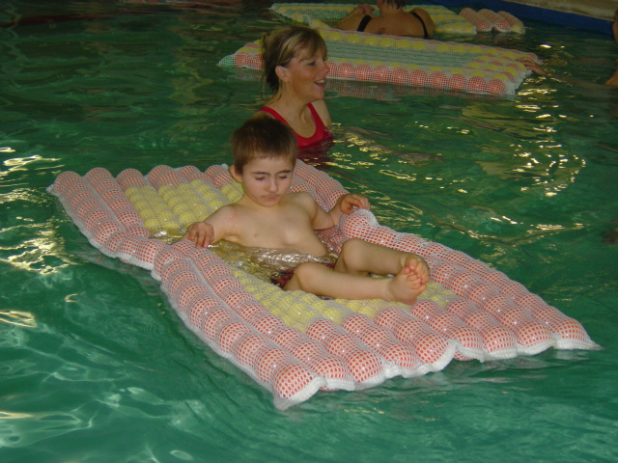
- Introduction
- A demonstration of all Floatsation devices in the water
- The opportunity for participants to work with the devices
- A demonstration of Floatsation devices with students
- Hands on training for participants
- Review and a Q&A session
Places on this FREE course will be reserved on a priority basis. (i.e. we prefer to offer training to staff/ volunteers who will then be able to offer Floatsation to disabled beneficiaries). Please complete the attached form to apply for a place. Contact Fiona Hall fhall@fdso.co.uk 01924 37238

APPLICATION TO ATTEND THE WEST YORKSHIRE FLOATSATION TRAINING COURSE AT BATLEY SPORTS AND TENNIS CENTRE ON WEDNESDAY 14TH MAY 1PM-3PM

Name

Organisation & Address

E mail

Tel no.

Please give details of why you wish to attend this course, and who will benefit as a result (i.e. Are you likely to be working with disabled people, using Floatsation, as a result of attending this course? Where? How often? How many people will benefit?)

Please provide any other relevant information

Return this form to Fiona Hall, Federation of Disability Sports Organisations, South Side Hospitality Suite, Rapid Solicitors Stadium, Doncaster Rd, Wakefield WF1 5EY
Or by e mail to fhall@fdso.co.uk 01924 372382

Closing Date 25th April. Successful candidates will be notified by May 1st
Please do not reserve a place on this course unless you are definitely available to attend.

